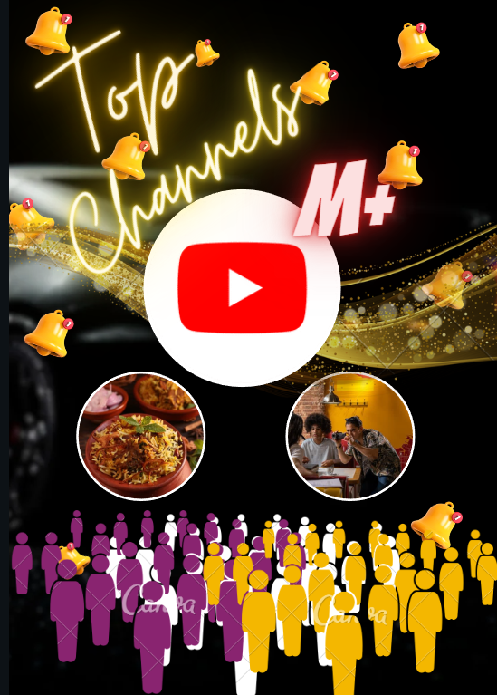

TITLE

**SUBSCRIBERS GALORE:**

**EXPLORING THE**

**WORLD’S**

**TOP MOST**

**YOUTUBE CHANNELS**

**introduction**

Welcome to our project, a thrilling expedition through the vibrant mosaic of the world's top YouTube channels. From the English-language powerhouses with staggering subscriber counts to the hidden gems in languages spanning the globe, we'll embark on a quest to uncover the most influential voices on this global platform. Each channel, a digital powerhouse in its own right, bridges cultures, educates, entertains, and inspires millions. Join us as we unravel the linguistic diversity and creative ingenuity of these channels, where subscriber counts reach astronomical figures, breaking barriers and connecting people worldwide. Welcome to the crossroads of YouTube's multilingual, subscriber-rich tapestry.

**Purpose**

Content Creation Guidance:

It serves as a valuable resource for aspiring content creators and digital marketers, offering guidance on how to create compelling and subscriber-attracting content.

Industry Benchmark:

By benchmarking the best practices of top channels, the project contributes to the digital content industry's growth and development.

Data-Driven Decision Making:

It enables data-driven decisions for content creators, marketers, and YouTube influencers, empowering them to enhance their strategies.

Audience Engagement Understanding:

By examining audience behavior and preferences, the project helps creators better connect with their viewers and grow their channels.

**Problem definition & design thinking**

**empathy map**

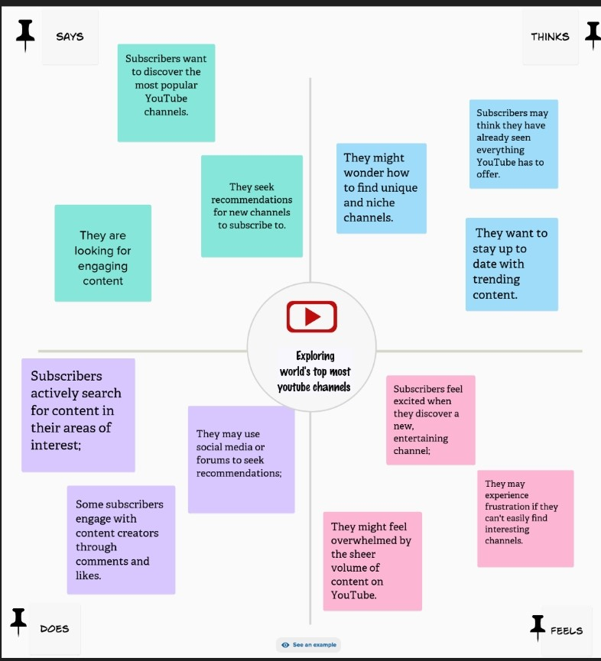

An empathy map is a visual tool used to gain a deeper understanding of a specific target audience or user by capturing their thoughts, feelings, needs, and behaviors, fostering empathy and enhancing the design and marketing processes.

**ideation and brainstorming map**

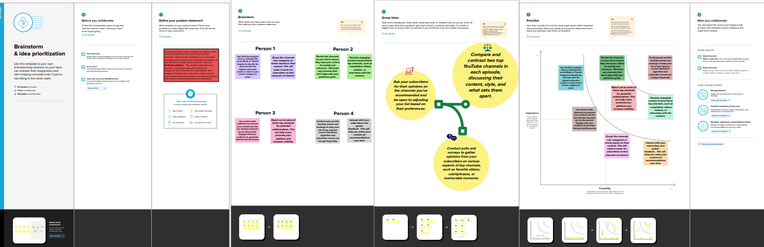

Brainstorming is a creative problem-solving technique that involves a group of individuals generating a large quantity of ideas, often in a free and unfiltered manner, to address a particular challenge or explore new opportunities. It encourages open and collaborative thinking.

**Result**

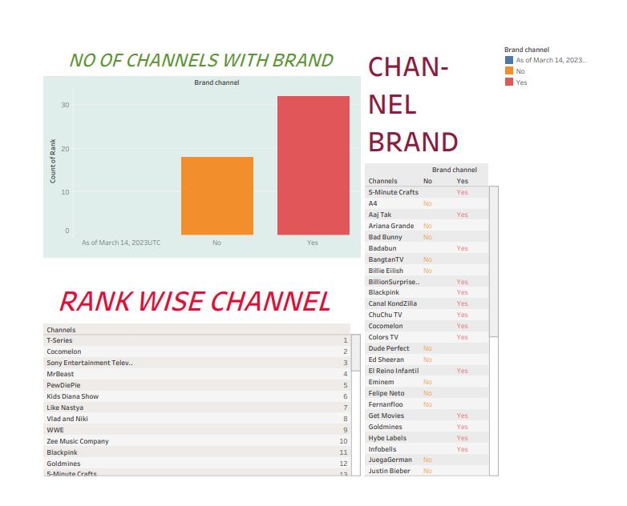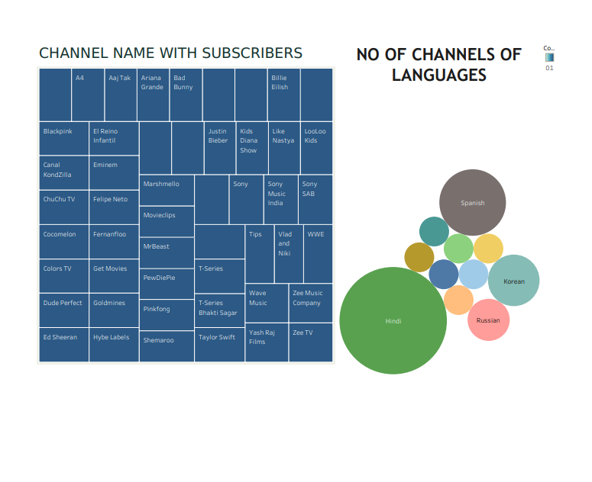

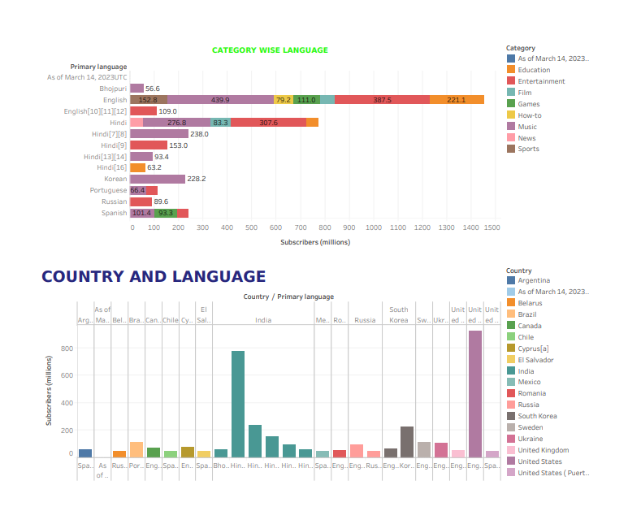

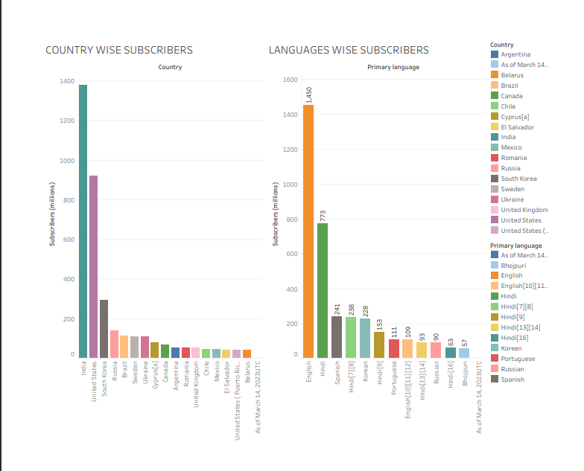

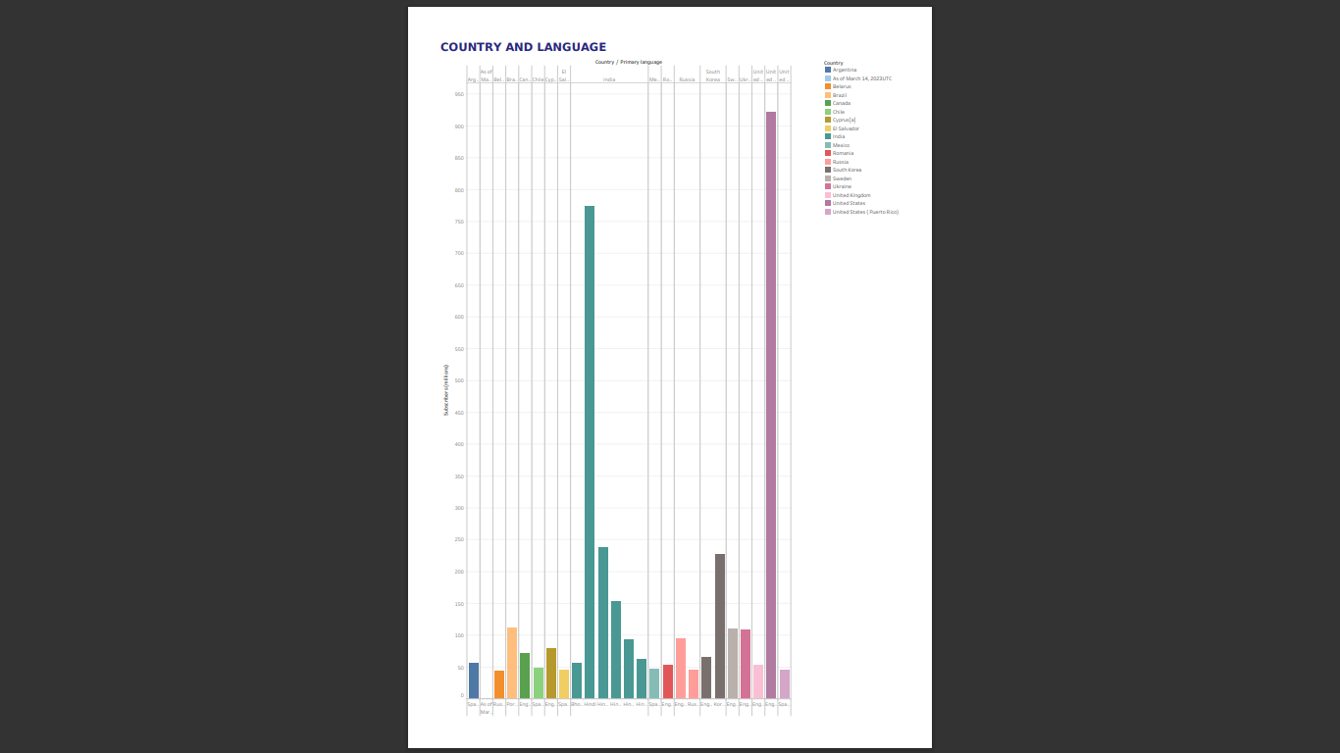

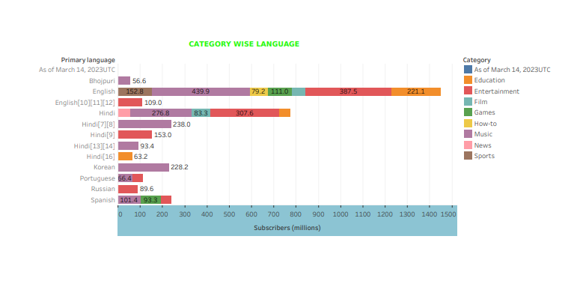

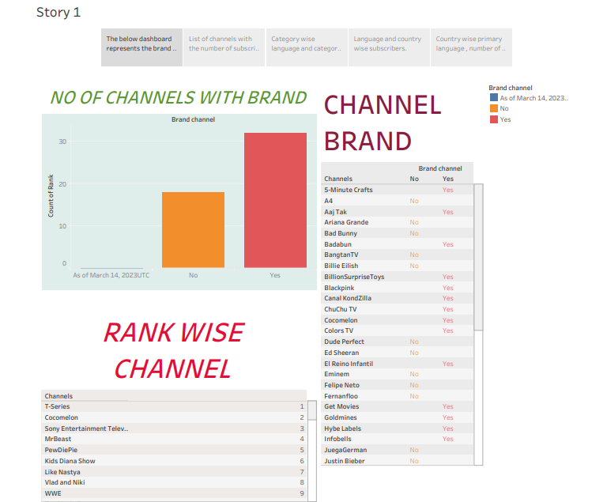

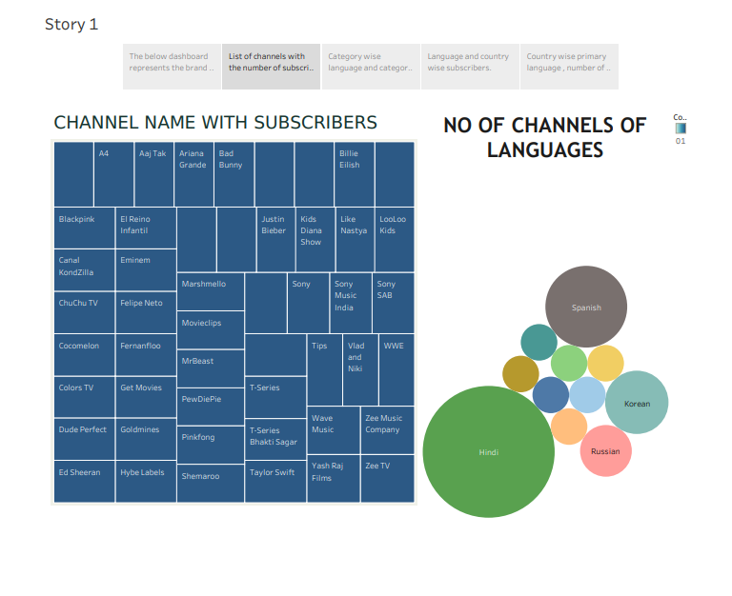

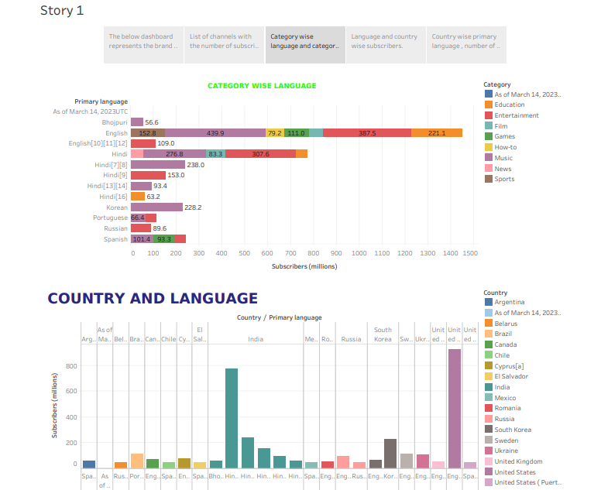

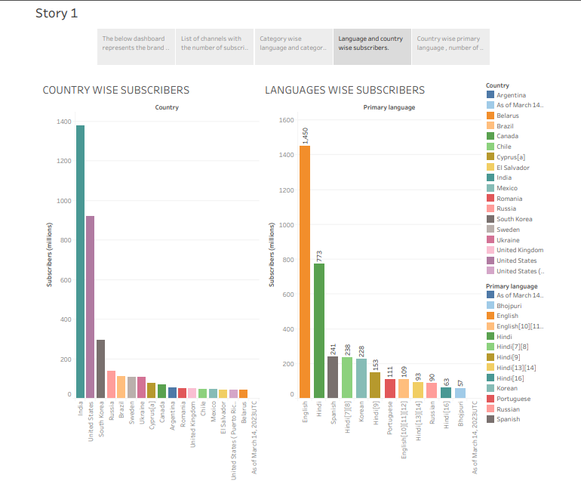

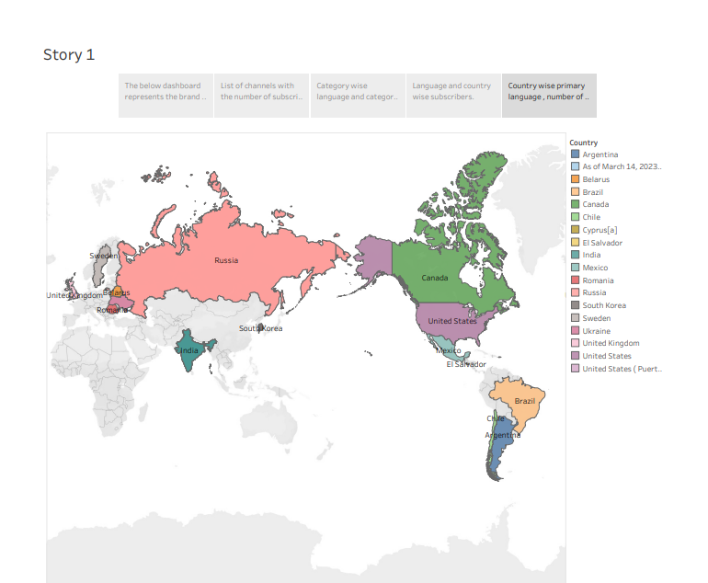

**Advantages**

Market Demand:

There is a strong demand for information and insights into the world's top YouTube channels. Many people aspire to become successful YouTubers, making this project relevant and potentially profitable.

Monetization Opportunities:

You can monetize the project through various means such as advertising, affiliate marketing, or by creating and selling guides or courses based on your research.

Influencer Collaboration:

Building a project around top YouTube channels can provide opportunities for collaboration with influencers, which can expand your reach and credibility.

Audience Growth:

By sharing valuable insights and analysis, you can attract a large audience interested in YouTube and social media, potentially increasing your own subscribers and followers.

Research Skills Development:

Conducting research on top YouTube channels can enhance your analytical and research skills, which can be valuable in other aspects of your professional life.

**Disadvantages**

Competitive Niche:

The YouTube analysis niche is competitive, with many established players. Gaining visibility and traction can be challenging.

Ever-Changing Landscape:

YouTube's algorithms and top channels are constantly evolving. Keeping up with the changes and maintaining accurate information can be time-consuming.

Copyright and Fair Use:

Analyzing and using content from top YouTube channels may involve copyright issues, and you might have to be careful about fair use and proper attribution.

Data Availability:

Access to data about top YouTube channels may be limited, making comprehensive research challenging.

Monetization Challenges:

Generating income from the project can be difficult, especially in the beginning. You may need to invest time and resources before seeing significant returns.

Ethical Considerations:

Some content creators may not want their channels analyzed, or they might be sensitive to criticism, which could lead to backlash or ethical dilemmas.

To succeed with the "Subscribers Galore" project, it's essential to carefully consider these advantages and disadvantages and plan your approach accordingly. Engaging with your target audience, continuously updating your knowledge, and maintaining ethical standards will be crucial for long-term success.

**Applications**

Content Creators:

Aspiring YouTubers and content creators can learn from the success stories and strategies of top YouTube channels, helping them improve their own content and grow their audiences.

Marketers:

Digital marketers may use such insights to understand how YouTube channels build their audiences, engage viewers, and monetize their content, potentially applying these strategies to their own campaigns.

Researchers:

Academics and researchers interested in online content creation and social media could use this resource to analyze the trends and dynamics of top YouTube channels.

Enthusiasts:

Fans of popular YouTubers might enjoy learning more about their favorite content creators, discovering behind-the-scenes information, and gaining a deeper understanding of their success.

General Audience:

It might also appeal to a general audience interested in pop culture, the impact of social media, and the evolving media landscape.

**Conclusions**

In conclusion, "Subscribers Galore: Exploring the World's TopYouTube Channels" offers not only a fascinating project but also a wide array of future opportunities. The knowledge gained can be applied to enhance the content creation and digital marketing landscape, making it more data-driven and efficient. With the rapid evolution of online content, this project's findings have the potential to shape the future of digital media. I am eager to be a part of this journey and contribute to the project's success.

**Future scope**

Data-Driven Insights:

This project sets the stage for continuous data analysis and provides an opportunity to develop predictivemodels to understand subscriber growth and trends.

Innovation and Strategy:

The insights gained can be leveraged by content creators and marketers to develop innovative strategies for growing YouTube channels and engaging audiences.

Monetization Opportunities:

By understanding what makes top channels successful, there's potential to unlock new revenue streams and help emerging creators monetize their content effectively.

Audience Behavior Analysis:

The project could lead to deeper insights into viewer behavior, helping channels tailor their content to attract and retain subscribers.

Content Trends:

The study can be used to forecast content trends, guiding creators to produce videos that are more likely to go viral and gain subscribers.

Cross-Platform Integration:

Insights can be applied to other social media platforms, creating opportunities for integrated cross-platform strategies.

International Expansion:

Expanding the project's scope to explore top YouTube channels in different regions can uncover global content trends and strategies.

AI and Machine Learning Integration:

The project can evolve to include the use of AI and machine learning for more advanced analysis and predictions.

Educational Resources:

Findings can be transformed into educational resources and training for aspiring content creators and digital marketers.

Industry Consultation:

The research can be a basis for industry consultation, assisting YouTube channels, digital marketing agencies, and businesses to enhance their online presence.